**State**

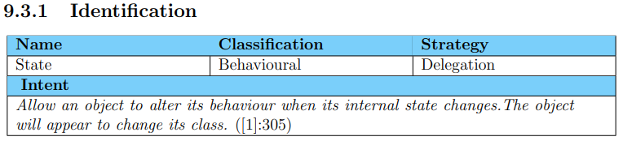

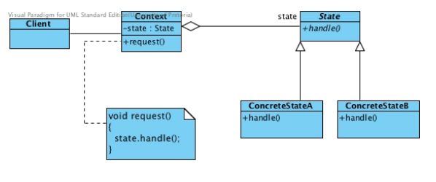

* Used for:
  + When an object becomes large
  + Extensive number of state changes
* Participants
  + State
  + ConcreteState
  + Context
* Polymorphism
* Client should not interact directly with states
* Improvements
  + Maintainability
  + Eliminate large conditional statements
  + Makes state transitions explicit
* Cons:
  + Higher coupling
* Implementation issues
  + Context applying fixed criteria
  + 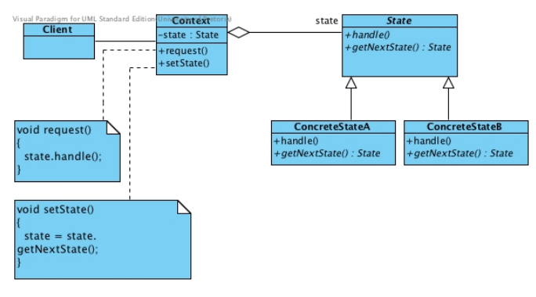
  + Context applying variable criteria
  + 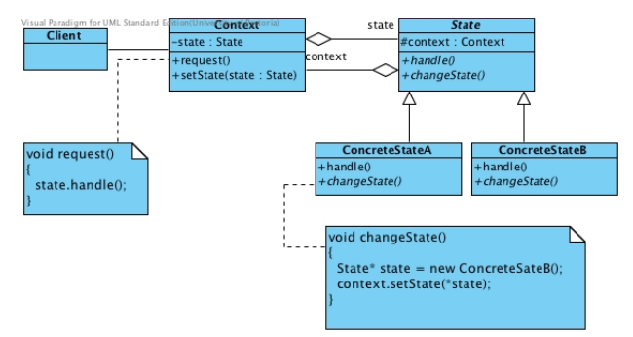
  + Concrete states applying variable criteria
* State objects can be shared
* A common implementation trade-off worth considering is whether (1) to create State objects only when they are needed and destroy them thereafter versus (2) creating them 6 ahead of time and never destroying them
* Related patterns
  + Strategy
  + Singleton or prototype
  + Flyweight

**Example**



